The exercise provided practical experience with password-cracking techniques and demonstrated how weak passwords can be vulnerable to cracking attempts. It also reinforced the importance of using strong, unique passwords to protect sensitive information.
This project focused on password cracking using John the Ripper (JTR) to crack the password of protected PDF files.
John the Ripper (JTR) is a popular password-cracking tool used by cybersecurity professionals to assess password strength and identify weak passwords. It supports different password hashes and can also recover passwords from protected files such as PDFs, ZIP files, and Microsoft Office documents.
Johnny is the graphical interface (GUI) for John the Ripper, making it easier for beginners to use through a simple point-and-click interface.
In this lab, I used John the Ripper and Johnny to recover the password of a password-protected PDF file. The exercise gave me practical experience in understanding how password-cracking techniques work and demonstrated the importance of using strong and unique passwords that are difficult to guess or discover through dictionary-based attacks.
I download John the Ripper and Johnny GUI from their official website on my PC: https://www.openwall.com/john or https://distro.ibiblio.org/openwall/projects/john/1.9.0
http://www.openwall.info/wiki/john/johnny
Run the setup file and install Johnny as shown in the following steps below
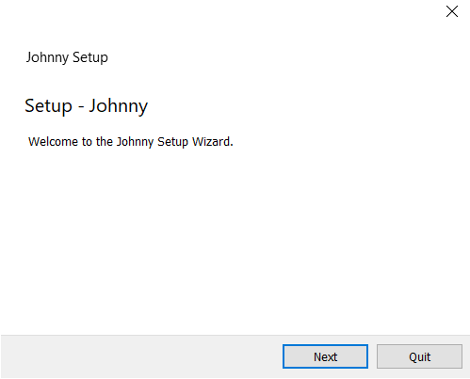



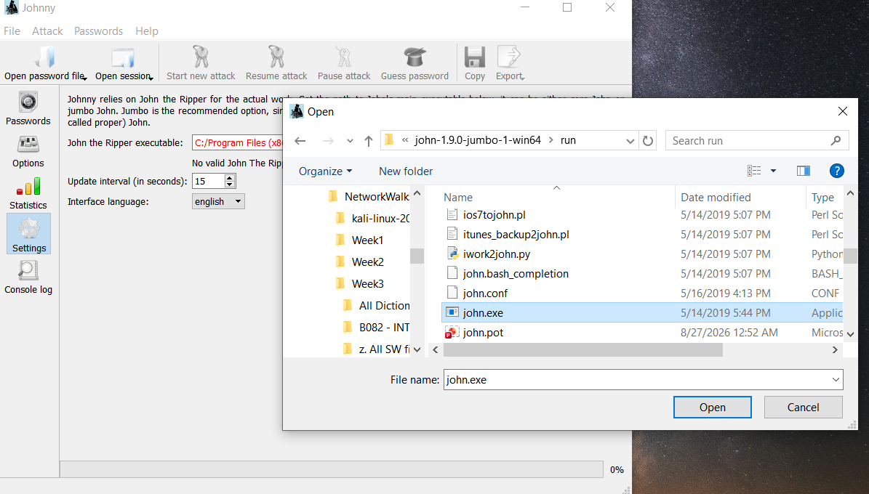

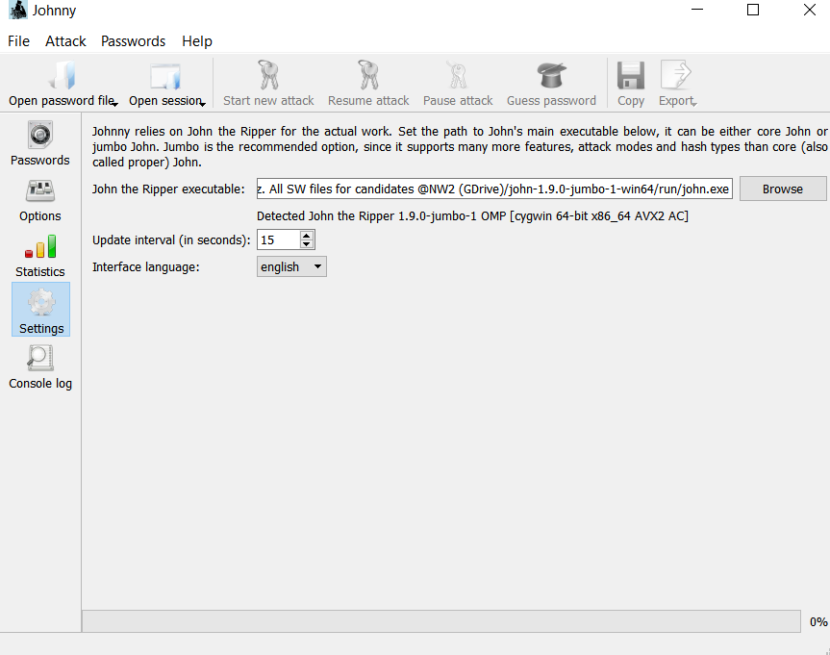

After the installation of Johnny, you open the hash website.
https://www.onlinehashcrack.com/password-recovery-service.php
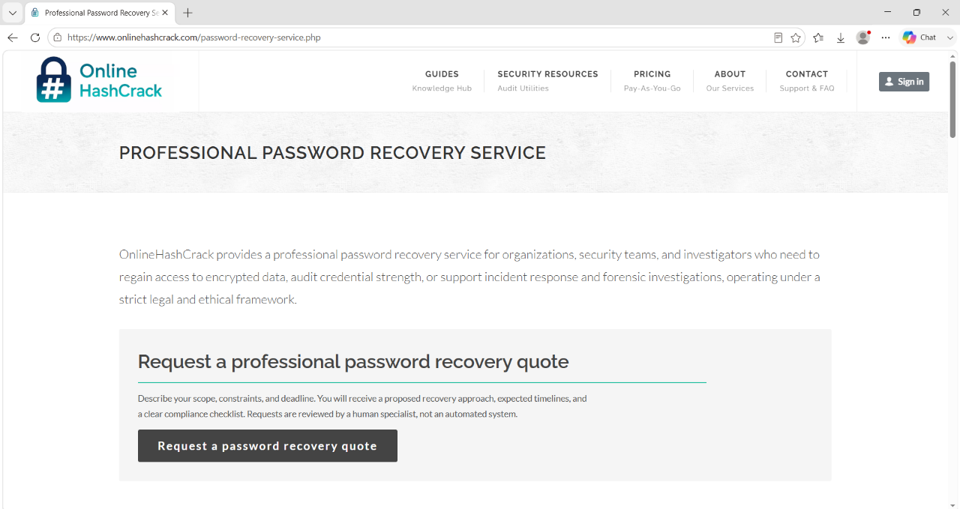

Browse the PDF file and then click on upload to find its hash.
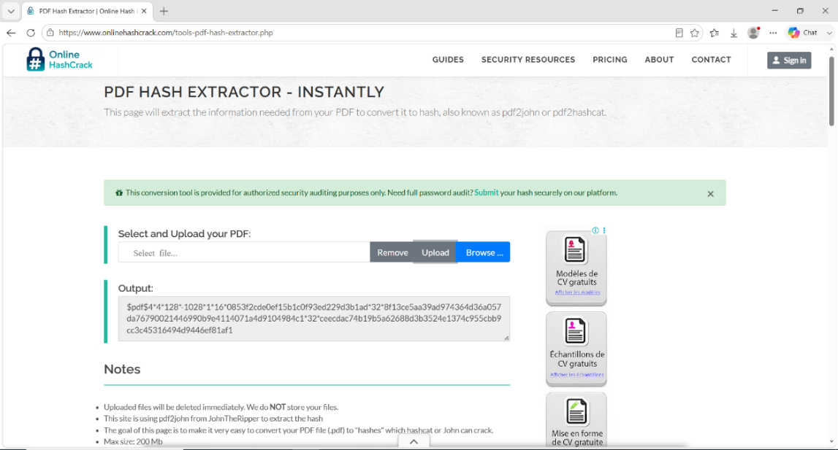

Select and copy the hash valve as shown, make sure to copy all the characters starting from $pdf$ as shown above.

Open a Notepad, then paste the hash value inside the Notepad, then save the text file with a name (My Locked Hash.txt)
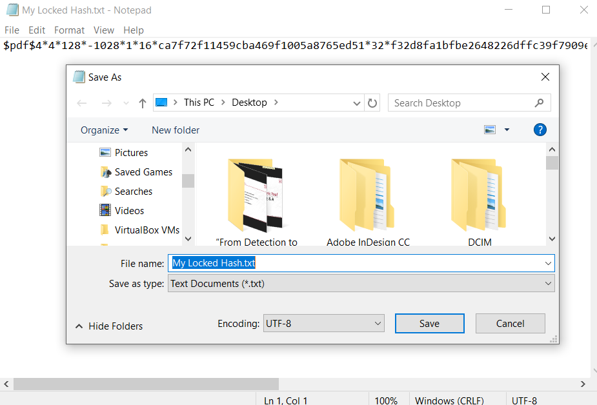

Open Johnny, the GUI for John the ripper and browse to upload your text file (My Locked Hash.txt) containing the hash extracted from the protected PDF file.
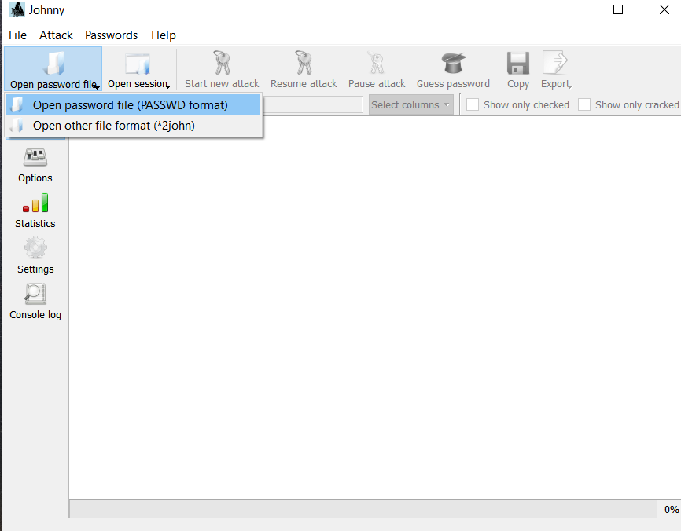

After uploading the file, JTR begins the password-cracking process.
Johnny then scanned through the available password combinations and identify the correct password (good-luck) as shown below.
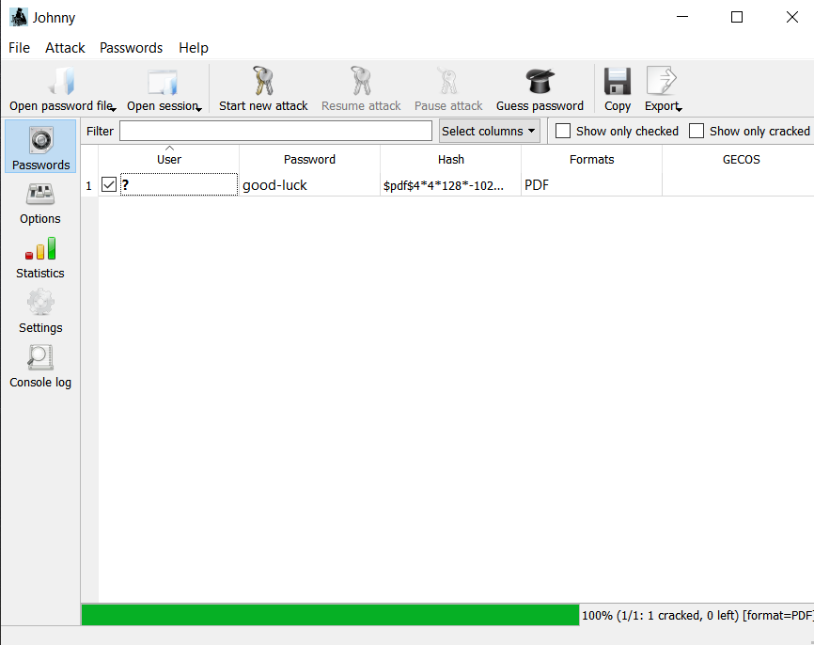

Open your PDF file (My Locked PDF1) with the password (good-luck) when prompted, this will successfully open the protected PDF file.


